Document For multiclock Timing Analysis:

P_reg

n_reg

q_reg

Schematic:

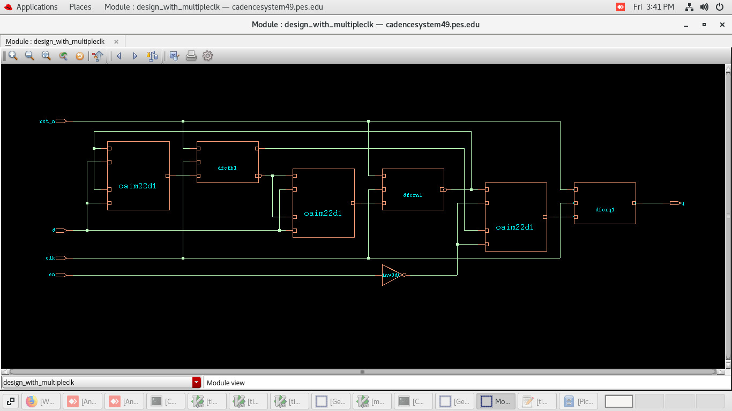

**1) n_reg to q_reg**

Command to open the timing report : report_timing -from n_reg -to q_reg

To save the timing report : > timing_report1

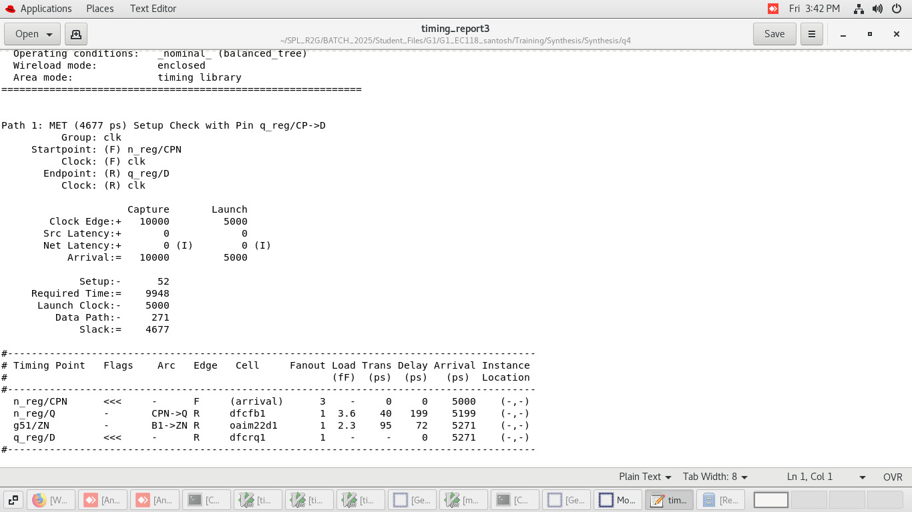

Formula:

AT= T/2 + 196+70=5000+199+72=5271ps

RT = 10000 – Tsetup = 10000 -52 =9948ps

Setup Slack = RT- AT = 9948-5271 = 4677ps

Data path = 199+72=271ps

**2) n_reg to p_reg**

Command to open the timing report : report_timing -from n_reg -to p_reg

To save the timing report : > timing_report2

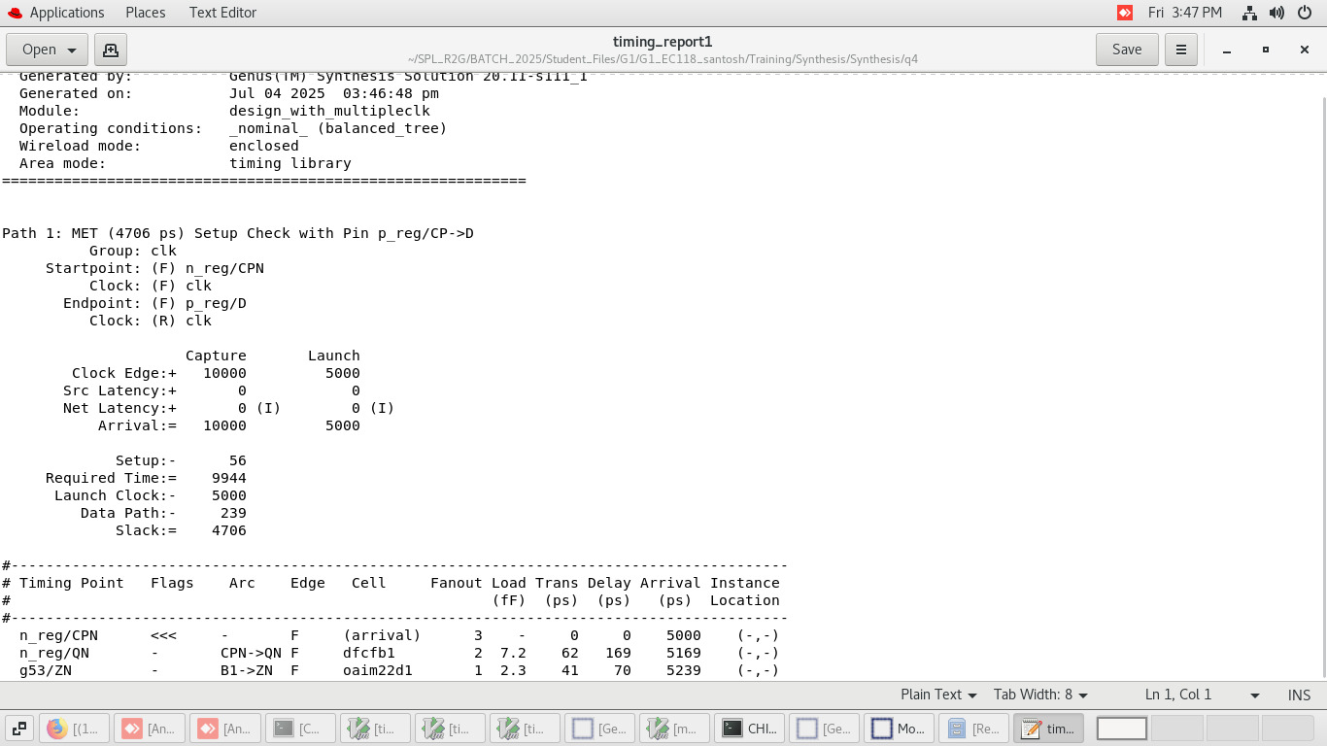

Formula:

AT= T/2 + 169+70=5000+169+70=5239ps

RT = 10000 – Tsetup = 10000 -56 =9944ps

Setup Slack = RT- AT = 9944-5239 = 4705ps

Data path = 169+70=239ps

**3) p_reg to q_reg**

Command to open the timing report : report_timing -from p_reg -to q_reg

To save the timing report : > timing_report3

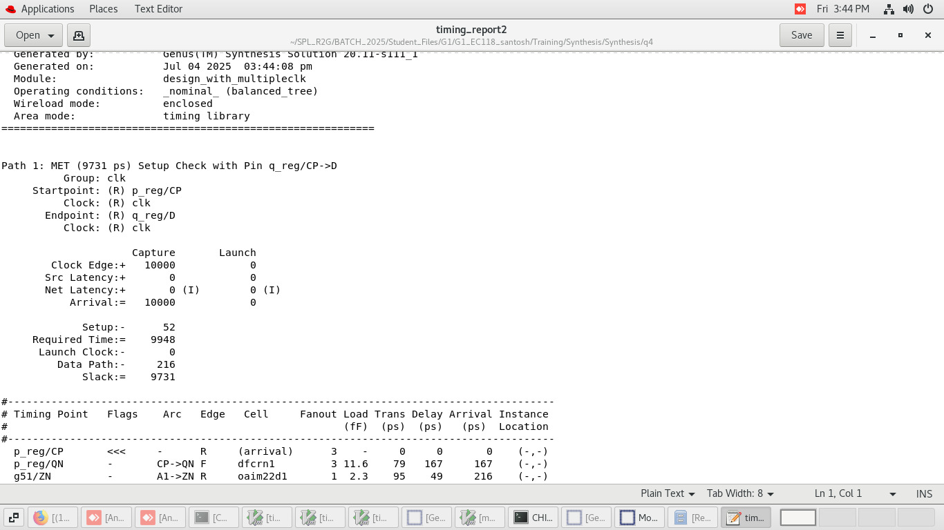

Formula:

AT= T/2 + 167+49=5000+169+70=5216ps

RT = 10000 – Tsetup = 10000 -52 =9948ps

Setup Slack = RT- AT = 9948-5216 = 4732ps

Data path = 167+49=216ps